1. 
2. 
3. 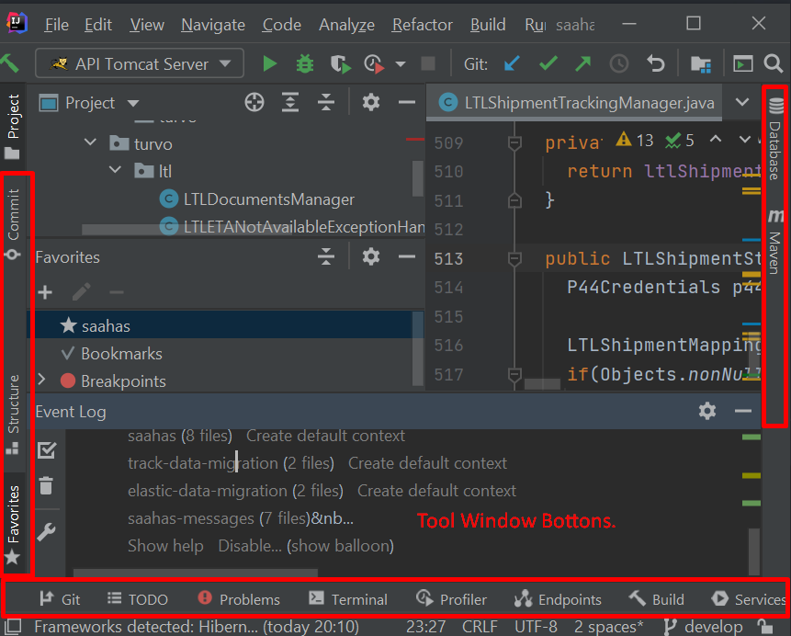
4. 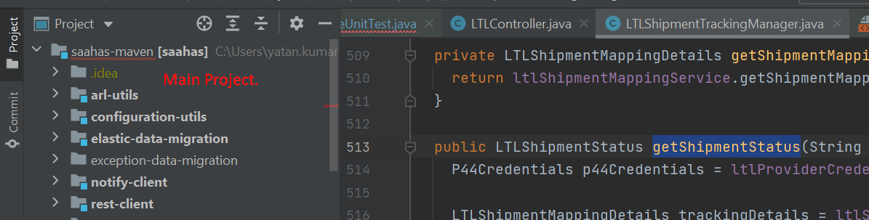
5. 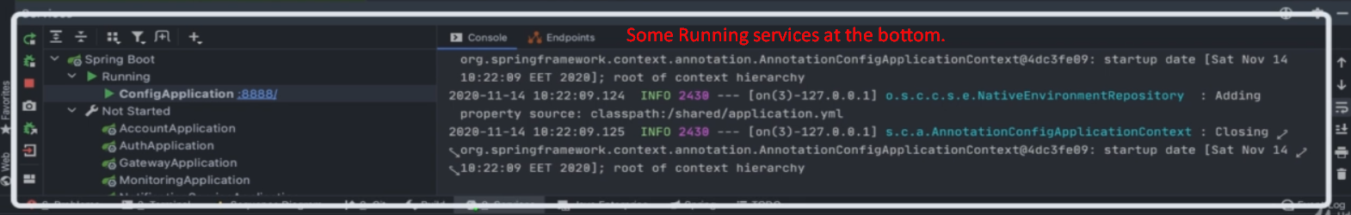
6. 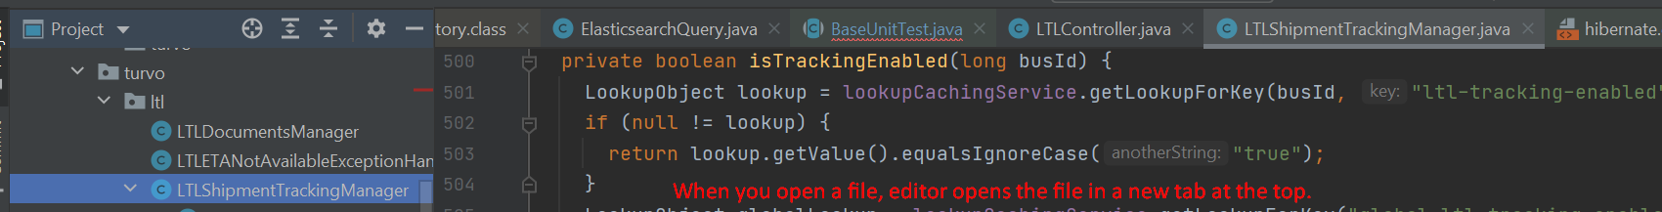
7. **Breadcrumb Trail:**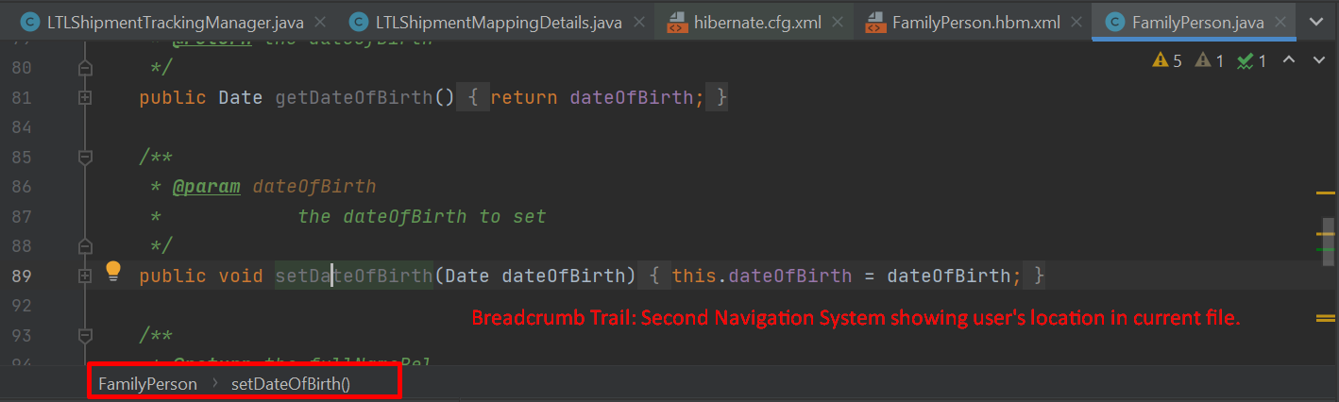
8. You can use all these features to navigate intellij Idea but they distract our attention from the main thing which is where we write code.